Boolean Ops
Perform CSG Operations on Meshes

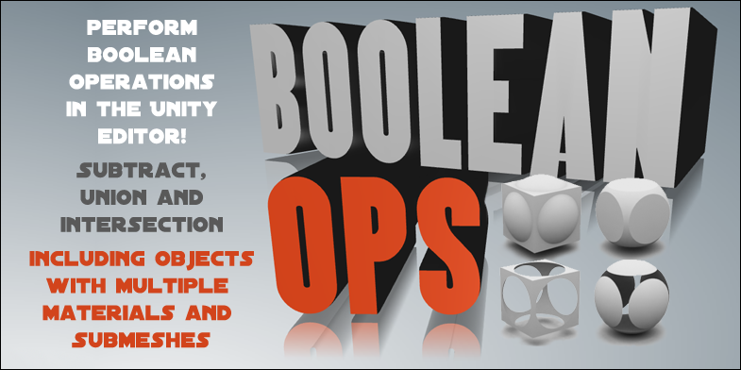

Boolean operations allow you to create new meshes by performing Subtraction, Union and Intersection between objects.

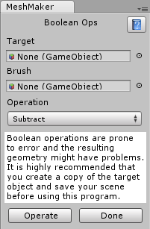
All creation is done in the editor and the resulting geometry preserves the texture UV coordinates of the original meshes. The program also handles rotated and scaled objects as expected and is suitable for objects with multiple materials and submeshes.

Starting Boolean Ops
To start using Boolean Ops click on the Window menu item, scroll down to the Boolean Ops item and then click on Open Window.

Performing Boolean Operations
Select the game object you want to operate on (with a Mesh Filter attached) from the hierarchy window and drag it into the Target slot. Do the same for the game object you want to use as a brush and drag it into the Brush slot. Choose the type of operation you want to perform from the drop down list and then click on the button marked Operate.

You may also need to move the brush used in the operation out of the way to see the resulting mesh.

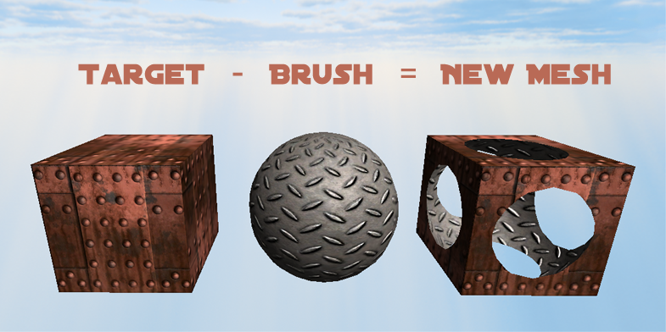

Notes
There is no undo function yet but that will be the next addition to the program.

FAQ
It is not recommended to do more that a few operations on the same target object or the geometry may become corrupted.

While the program works well on simple objects it may fail on very complicated objects, objects with underlying problems in their geometry. It is highly recommended that you make a copy of the target object and save your scene before using this software.

To learn more about Boolean Ops and to view the tutorial videos you can visit MeshMaker.com

